"The Ultimate North Sikkim Escape”
(6N/7D)

Discover the beauty of Sikkim and Darjeeling, where majestic Himalayan peaks, serene monasteries, and lush tea gardens create an unforgettable holiday. Explore the vibrant city of Gangtok, visit the stunning Tsomgo Lake and the sacred Baba Harbhajan Singh Mandir, and admire spectacular mountain landscapes. Continue to the charming hill station of Darjeeling, famous for its rolling tea estates, colonial charm, and panoramic views of Mt. Kanchenjunga.

Witness the mesmerizing sunrise from Tiger Hill, visit the historic Ghoom Monastery and the iconic Batasia Loop, and experience the rich culture of the Eastern Himalayas. Perfect for families, couples, and nature lovers, this journey offers the ideal blend of scenic beauty, adventure, and relaxation, creating memories to cherish for a lifetime.

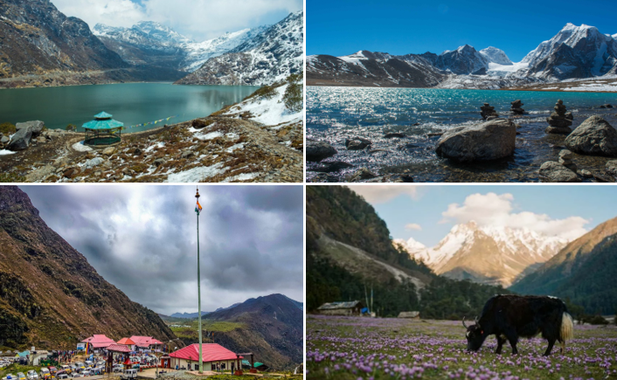

We wish you a happy, safe and unforgettable journey with us
Detailed Itinerary
Day 1: NJP / Bagdogra – Gangtok (130 Km | 4.5 Hrs approx.)
Upon arrival at New Jalpaiguri (NJP) Railway Station or Bagdogra Airport, meet our representative and drive to Gangtok, the capital of Sikkim. Enjoy a scenic journey along the Teesta River, passing lush green valleys and picturesque mountain landscapes. Upon arrival, check in to your hotel and spend the evening at leisure exploring the vibrant MG Marg. Overnight stay in Gangtok.
Day 2: Gangtok Sightseeing
After breakfast, visit the breathtaking Tsomgo Lake and the revered Baba Harbhajan Singh Mandir. If permits are available, guests may also visit Nathula Pass (optional and at an additional cost). Return to Gangtok for an overnight stay.
Day 3: Gangtok – Lachen
After an early breakfast, drive to the beautiful mountain village of Lachen. En route, witness spectacular waterfalls, lush valleys, and scenic mountain landscapes, including stops at Seven Sisters Waterfall, Naga Waterfall, and Chungthang. Check in to the hotel upon arrival. Overnight stay in Lachen.
Day 4: Lachen – Gurudongmar Lake – Lachung
Early in the morning, visit the magnificent Gurudongmar Lake, one of the highest lakes in the world, surrounded by snow-covered Himalayan peaks. Return to Lachen for breakfast before continuing your scenic drive to Lachung. Check in to the hotel and relax. Overnight stay in Lachung.
Day 5: Lachung – Yumthang Valley – Gangtok
After breakfast, visit the enchanting Yumthang Valley, popularly known as the "Valley of Flowers." Surrounded by alpine meadows, rhododendron forests, and majestic mountains, the valley offers breathtaking views throughout the year. Later, drive back to Gangtok. Overnight stay in Gangtok.
Day 6: Gangtok Leisure Day
After breakfast, enjoy a relaxed day in Gangtok. You may explore MG Marg, visit local cafés, shop for handicrafts and souvenirs, or opt for local sightseeing such as Rumtek Monastery, Hanuman Tok, Ganesh Tok, Tashi View Point, and the Namgyal Institute of Tibetology (optional). Overnight stay in Gangtok.
Day 7: Gangtok – NJP / Bagdogra Departure
After breakfast, check out from the hotel and transfer to NJP Railway Station or Bagdogra Airport for your onward journey. Depart with unforgettable memories of the majestic Himalayas, pristine lakes, picturesque valleys, and the natural beauty of North Sikkim.
Tour ends with unforgettable memories
Destination/Nights | 3* Hotel Name
Gangtok /04N
Lachen /01N
Lachung /01N
HOTELS DETAILS:

Package Cost:

3★ Hotels: Rs. per person (Based on 6 guests – Double Sharing Basis)

Inclusion: -
- Breakfast.
- 0 DBL Room on sharing based.
- 06 Nights in Accommodation in hotel.
- Assistance on Arrival.
- Permit.
- All Transfers and S.S tours by AC Tempo Traveler
Exclusions: -
- 5% GST.
- Flight Tickets are not included.
- Guide.
- Extra meal not included or as per the inclusions given above.
- Vehicle not at disposal.
- No extra pickup or drop included for lunch/sightseeing unless otherwise mentioned in the itinerary.

